Issue 4 – What’s on in the Local Community

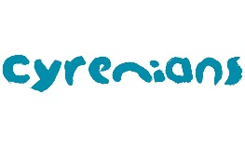
Cyrenians New Young Adult Service (YAS)

Cyrenians has launched their new Young Adult Service (YAS), designed specifically to work with young people aged 16-24years (26years old if care experienced) across the Falkirk and District area.
The service has been developed to target this specific age group and the challenges they have experienced in recent years, through an activity-based project which allows for social interaction and development opportunities. Activities will include a 12 week personal development programme, days and nights out, social events and the opportunity to try new things. For those young people not yet ready to join groups, Cyrenians will work with them on a one to one basis, to improve their confidence, and build trust and rapport with young people to help them build enough self-assurance to take part in groups
The service also aims to empower young people with the skills, knowledge and self-confidence to be independent, making positive and healthy choices. To do this, Cyrenians will deliver a variety of awareness sessions and accredited learning on mental health, communication skills, active citizenship, amongst others. Part of the service’s provision will also ensure that young people have access to services to enable this process (eg. a Young Scot card for free travel).
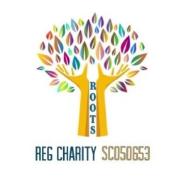
For further information, please contact Maria Ferrari by phone: 01324 323323, or email: mariaferrari@cyrenians.scot
Bonnybridge Community Café up and running
A new community café in Bonnybridge Community Centre started last Monday 9th March 2023. This café will run weekly so please encourage people to come along every Monday. People can drop in anytime between 11am-2pm.
There will be refreshments and cakes provided. This café is for the community but is supported by local charity Roots. There is no charge for coming along to the café.

Community Transport

Dial A Journey offer a door to door service as an alternative for people who are unable to use public transport. The service can be used for almost any purpose but may include things like attending community groups, medical appointments, having a meal out, going to church, shopping or visiting friends. All members using dial a journey can also bring one escort with them if required. There is a lot of availability of drivers during school hours but they can be busy at school drop off and pick up time. The service operates from 7.45am-5pm Mon-Fridays. It can be possible to travel out with these times with special arrangement by phoning the Dial a journey number on 01786 465355. To download the dial a journey application form click here
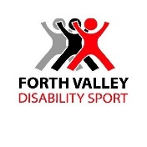
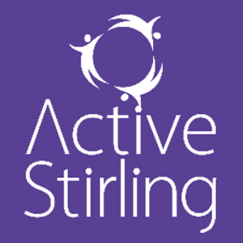
Without Barriers Multi Sports Sessions

A partnership project between Active Stirling and Forth Valley Disability Sport are offering a free 16 week block of multi-sport sessions from March 3rd to 30th June (excluding 7th and 14th April 2023) for people over the age of 16yrs living with a disability or impairment.

Day/Date: Friday 3rd March to 30th June 2023 (Excluding 7th/ 14th April)

Start time: 10:30am – 12:30pm

Venue: The Peak Sport Village, Stirling

Format- Drop in anytime, no booking required but we will ask for some sign up details for regular attendees

Cost: free

Age Group- 16+ living with a disability or impairment

Further Info – please contact Christopher on bwb@activestirling.org.uk

